**Assignment 4 by script**

**Script –**

pipeline {

agent none

stages {

stage('repo-1') {

agent {

label 'built-in'

}

steps {

ws('/mnt/pipeline-1') {

git branch: 'main', url: 'https://github.com/prasadpawar252/repo1.git'

sh '''

sudo yum install httpd -y

sudo service httpd start

sudo rm -rf /var/www/html/*

sudo cp index.html /var/www/html/

sudo chmod 777 /var/www/html/index.html

'''

}

}

}

stage('repo-2') {

agent {

label 'slave-1'

}

steps {

ws('/mnt/pipeline-2') {

git branch: 'main', url: 'https://github.com/prasadpawar252/repo-2.git'

sh '''

sudo yum install httpd -y

sudo service httpd start

sudo rm -rf /var/www/html/*

sudo cp index.html /var/www/html/

sudo chmod 777 /var/www/html/index.html

'''

}

}

}

}

}

This Jenkins pipeline clones two GitHub repositories (repo1 and repo-2) on two different agents, installs and starts Apache (httpd), and copies each repo's index.html file to /var/www/html/ to serve via a web server.

Final console output-

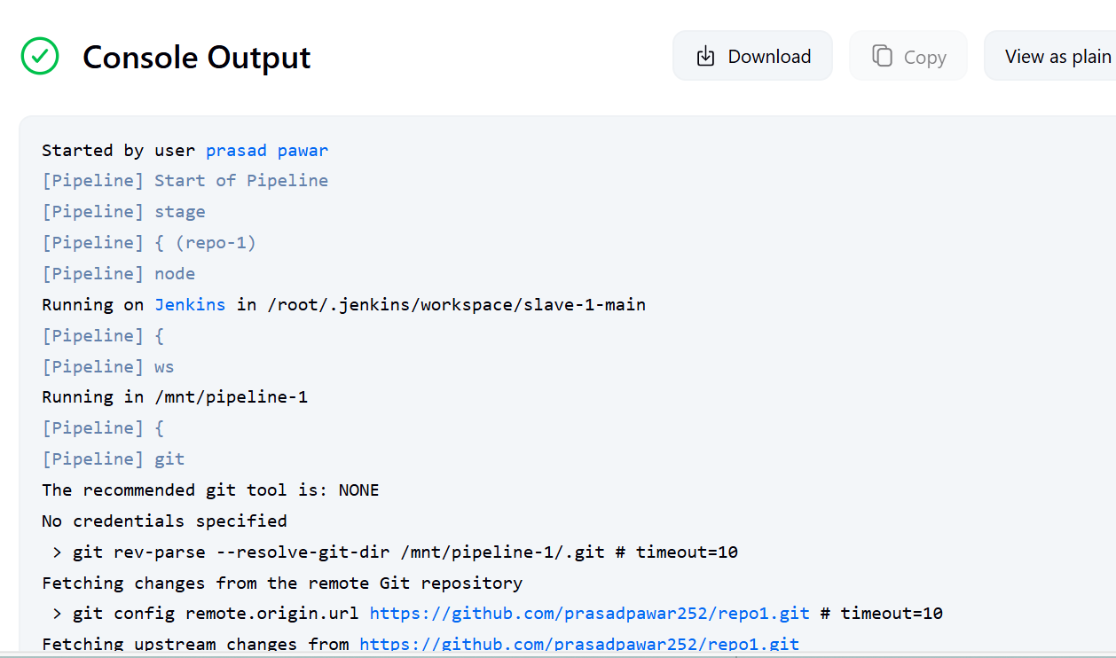

Slave 1 Final output –

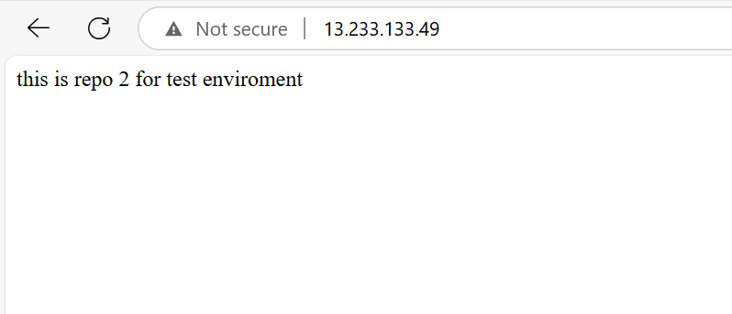

Master Final output –

